VISVESVARAYA TECHNOLOGICAL UNIVERSITY
BELAGAVI – 590018


A PROJECT REPORT ON
“PHANTOM PHOENIX”
Digital Media Authenticity and AI Forensic Intelligence Platform
Submitted in partial fulfillment of the curriculum prescribed for the award of the degree of
BACHELOR OF ENGINEERING
in
ARTIFICIAL INTELLIGENCE AND MACHINE LEARNING
Submitted by
Hari ____________________ USN: ____________________
Shreyas __________________ USN: ____________________
Shree Raksha ______________ USN: ____________________
Srinivas ___________________ USN: ____________________
Under the guidance of
Guide name and designation: TO BE COMPLETED
Department of Artificial Intelligence and Machine Learning
JYOTHY INSTITUTE OF TECHNOLOGY, BENGALURU
Academic Year: TO BE COMPLETED

JYOTHY INSTITUTE OF TECHNOLOGY
Department of Artificial Intelligence and Machine Learning
CERTIFICATE
This is to certify that the project work entitled “PHANTOM PHOENIX — Digital Media Authenticity and AI Forensic Intelligence Platform” is carried out by the students listed below, bonafide students of Bachelor of Engineering in Artificial Intelligence and Machine Learning at Jyothy Institute of Technology, Bengaluru, affiliated to Visvesvaraya Technological University, Belagavi, in partial fulfillment of the requirements for the award of the degree during the academic year TO BE COMPLETED.
Student | USN | Signature
Hari | TO BE COMPLETED | ________________
Shreyas | TO BE COMPLETED | ________________
Shree Raksha | TO BE COMPLETED | ________________
Srinivas | TO BE COMPLETED | ________________
Guide: Name, designation and credentials TO BE COMPLETED
Head of Department: Dr. Madhu B R (verify designation before submission)
Principal: Institutional approval details TO BE COMPLETED
Date: TO BE COMPLETED Place: Bengaluru
Examiner | Name | Signature
1 | TO BE COMPLETED | ________________
2 | TO BE COMPLETED | ________________

DECLARATION
We, the undersigned students of the eighth semester Bachelor of Engineering in Artificial Intelligence and Machine Learning at Jyothy Institute of Technology, Bengaluru, hereby declare that the project entitled “PHANTOM PHOENIX — Digital Media Authenticity and AI Forensic Intelligence Platform” has been carried out by us and submitted in partial fulfillment for the award of the degree of Bachelor of Engineering in Artificial Intelligence and Machine Learning under Visvesvaraya Technological University, Belagavi.
We further declare that the matter presented in this report has not been submitted previously by anybody for the award of any degree or diploma to any other university, to the best of our knowledge and belief. All technical results are reported with their evidence source and limitations.
Name | USN | Signature
Hari | TO BE COMPLETED | ________________
Shreyas | TO BE COMPLETED | ________________
Shree Raksha | TO BE COMPLETED | ________________
Srinivas | TO BE COMPLETED | ________________
Place: Bengaluru Date: TO BE COMPLETED

ACKNOWLEDGEMENT
We express our sincere gratitude to Visvesvaraya Technological University and Jyothy Institute of Technology for providing the academic environment and resources required to undertake this project. We thank the Principal, the Head of the Department of Artificial Intelligence and Machine Learning, our project coordinator, teaching staff and laboratory staff for their guidance and support.
We are especially grateful to our project guide, whose name and designation will be inserted after institutional verification, for technical direction, review and encouragement throughout the implementation and evaluation of PHANTOM PHOENIX. We also acknowledge the open-source communities and authors of the datasets, libraries and scientific works cited in this report.
Finally, we thank our families and friends for their encouragement.
Signatures of students: TO BE COMPLETED

ABSTRACT
PHANTOM PHOENIX is a web-based digital-media authenticity screening and AI forensic intelligence platform developed for image analysis. The system accepts a validated image upload, computes a SHA-256 content hash, performs image decoding and dimensional checks, applies a CommunityForensics ViT-Small binary detector, and runs complementary forensic analyzers for metadata, Error Level Analysis (ELA), noise residuals and frequency-domain statistics. Evidence is normalized into categories such as verified evidence, computed observation, heuristic evidence and unknown or unavailable information. A transparent verdict policy returns LIKELY_AI, LIKELY_REAL, INCONCLUSIVE or ANALYSIS_FAILED with a risk level and explicit non-claims. Results are persisted in PostgreSQL and can be exported as a ReportLab PDF investigator report.
The implementation includes authenticated browser workflows, scan history, structured API responses, audit events, rate limiting, visual forensic artifacts and attention-based explainability. A baseline evaluation manifest records 1,123 test images with accuracy 0.6705, precision 0.9956, AI recall 0.3788, F1-score 0.5488, ROC-AUC 0.8965 and PR-AUC 0.9176 at threshold 0.50; these values describe a dated repository evaluation, not universal detector performance. The principal limitation is generalization to newer generators and the fact that a classifier score cannot establish legal authenticity or identify a generator. Source discovery, publisher intelligence, external investigation evidence and generator attribution remain explicitly unsupported or unavailable. The platform therefore functions as a decision-support and evidence-organization tool rather than an infallible authenticity oracle.
Keywords: digital forensics, deepfake detection, Vision Transformer, metadata, ELA, evidence aggregation, explainable AI

TABLE OF CONTENTS
The editable Word field below can be refreshed in Microsoft Word or LibreOffice (Update Table of Contents). Chapter and front-matter headings are styled for navigation.
Chapter 1 Introduction
Chapter 2 Literature Survey
Chapter 3 Objectives and Methodology
Chapter 4 System Design
Chapter 5 Hardware and Software Requirements
Chapter 6 Implementation
Chapter 7 Testing, Results and Discussion
Chapter 8 Conclusion and Future Scope
References
Appendix A Evidence and Completion Checklist

LIST OF FIGURES
Figure 4.1 Overall system architecture
Figure 4.2 End-to-end image analysis workflow
Figure 4.3 Scan interaction sequence
Figure 6.1 Investigator landing page
Figure 6.2 Authenticated dashboard
Figure 6.3 Image upload interface
Figure 6.4 Authenticity result view
Figure 6.5 Metadata and evidence findings
Figure 6.6 Forensic artifacts view
Figure 6.7 Scan archive
Figure 7.1 PDF report download workflow
LIST OF TABLES
Table 3.1 Functional objectives
Table 4.1 Component responsibilities
Table 5.1 Software requirements
Table 6.1 API routes
Table 7.1 Baseline evaluation metrics
Table 7.2 Confusion matrix
Table 7.3 Verification evidence
Table 8.1 Proposed future scope

NOMENCLATURE AND ABBREVIATIONS
Term | Meaning
AI | Artificial Intelligence
API | Application Programming Interface
C2PA | Coalition for Content Provenance and Authenticity
CUDA | Compute Unified Device Architecture
ELA | Error Level Analysis
EXIF | Exchangeable Image File Format
FFT | Fast Fourier Transform
FPR | False Positive Rate
FNR | False Negative Rate
JWT | JSON Web Token
PDF | Portable Document Format
REST | Representational State Transfer
SHA-256 | Secure Hash Algorithm 256-bit
USN | University Seat Number
ViT | Vision Transformer

CHAPTER 1 INTRODUCTION

1.1 Background and Motivation
Digital images now move through social networks, messaging systems, marketplaces, newsrooms and evidentiary workflows at a scale where visual inspection alone is insufficient. Generative models can create synthetic scenes, alter faces, remove objects or retouch local regions with little visible trace. The practical problem is not merely deciding whether an image “looks real”; it is organizing technical observations, model inference, provenance clues and uncertainty so that a human investigator can review them.

1.2 Problem Statement
A user needs a controlled workflow to submit an image, validate its bytes, inspect content and metadata, obtain a model-based screening signal, review forensic artifacts, preserve a hash-linked record and export a readable report. Existing single-score demonstrations often obscure missing evidence and limitations. PHANTOM PHOENIX addresses this gap for image-only analysis while explicitly avoiding claims of absolute authenticity.

1.3 Proposed Solution
The platform combines a React/TypeScript client with a FastAPI service. The service validates and hashes the upload, invokes a pinned ViT-Small detector with CPU/CUDA fallback, runs modular forensic analyzers, aggregates evidence and applies a threshold policy. Results are stored as structured JSON and rendered in both a browser results view and a PDF investigator report.

1.4 Objectives
Objective | Description
O1 | Provide secure image upload and strict content validation.
O2 | Run reproducible AI-generated-image screening using a pinned model revision.
O3 | Expose metadata, ELA, noise and frequency observations with artifacts.
O4 | Separate evidence, interpretation, heuristic signals and unavailable capabilities.
O5 | Persist scan history and generate an editable workflow-compatible PDF report.
O6 | Validate behavior through unit, integration, browser and build checks.

1.5 Scope and Significance
Current scope is image analysis. Authentication, ownership, audit routes, scan history and report generation are implemented in the repository; administrator dashboard behavior and external provenance integrations are not treated as complete unless explicitly evidenced. Video, audio, C2PA verification, reverse-image search and defensible generator attribution are future work. The system is significant as a transparent screening aid for education, media triage and preliminary investigation.

1.6 Organization of Report
Chapter 2 reviews relevant research. Chapter 3 defines objectives and methodology. Chapter 4 presents architecture and data flow. Chapter 5 lists requirements. Chapter 6 explains implementation. Chapter 7 reports tests and dated evaluation evidence. Chapter 8 concludes and proposes future work.

CHAPTER 2 LITERATURE SURVEY

2.1 Deepfake and Synthetic-Media Detection
Deepfake detection research spans face manipulation, image synthesis, video temporal consistency and multimodal analysis. Generalization is difficult because generators evolve, post-processing changes artifacts and datasets can contain shortcuts. Coccomini et al. compare Vision Transformers and EfficientNetV2 in cross-forgery settings and report stronger generalization behavior for ViTs in several unseen-method conditions [1]. Heo et al. investigate transformer-based deepfake detection and distillation, showing the value of combining patch-level and visual features [2].

2.2 Vision Transformers
Vision Transformers divide an image into patches and use self-attention to model relationships between patches. Dosovitskiy et al. established the ViT formulation for image recognition [3]. In PHANTOM PHOENIX, the deployed detector is not trained by this project; it is used as a pinned external baseline and its output is treated as model inference with limitations. Attention-derived visualization is reported as focus, not ground-truth localization.

2.3 Image Forensics and Provenance
Forensic analysis can inspect compression residue, sensor or noise characteristics, frequency statistics, metadata and file integrity. These observations are useful context but are not independently decisive: social-media recompression and benign editing can produce similar effects. Metadata can be stripped or rewritten. Provenance standards such as C2PA use signed content credentials to bind assertions to assets, which differs from heuristic metadata inspection [4]. The current implementation does not verify C2PA credentials.

2.4 ELA, Noise and Frequency Analysis
ELA compares an image with a recompressed version to expose local residual differences. Noise analysis estimates residual statistics after high-pass filtering. Frequency analysis transforms pixel data into a spectral magnitude representation using a two-dimensional FFT. These techniques are implemented as computed or heuristic observations and must be interpreted alongside acquisition history and model results.

2.5 Explainability and Calibration
Explainability methods can help users understand where a model attends, but saliency is not proof of manipulation. The platform records attention rollout metrics and can generate a Grad-CAM-style attention artifact; the report labels this as attention focus. Calibration is also essential: a probability output is not automatically a real-world probability. The repository’s threshold study uses a validation set to select an operational low threshold, while evaluation metrics remain tied to explicit splits and manifests.

2.6 Research Gap and Positioning
PHANTOM PHOENIX does not claim a novel detector architecture or a complete provenance network. Its contribution is engineering integration: strict input handling, modular forensic evidence, explicit status values for unsupported investigation sections, authenticated persistence, auditability and report generation. This makes limitations visible rather than silently converting absent data into confidence.

CHAPTER 3 OBJECTIVES AND METHODOLOGY

3.1 Functional and Non-functional Objectives
Category | Requirement
Functional | Upload, decode, hash, infer, analyze, aggregate, persist and report.
Security | Cookie/JWT authentication, CSRF origin checks, rate limits and ownership checks.
Reliability | Explicit analysis failure state; no failure may become LIKELY_REAL.
Performance | CPU fallback; optional CUDA acceleration; bounded upload size.
Maintainability | Modular analyzers, Pydantic schemas, migrations and tests.
Scientific integrity | Every result tagged as verified, computed, heuristic or unavailable.

3.2 Inputs and Outputs
Input is an image submitted as multipart/form-data. Validation checks actual decodability, supported image type, maximum 5 MiB size and maximum 8192 pixels per side. The output contains input details, model outputs, explainability status, forensic indicators, normalized evidence, verdict, risk, limitations and investigator report sections.

3.3 Dataset and Provenance
Repository manifests document OpenFake-derived evaluation material and multiple experimental protocols. The current baseline evaluation manifest records 1,123 test samples: 529 real and 594 AI-generated, with zero inference errors. A separate corrected-protocol report records a 922-sample test protocol. Because these records represent different dataset snapshots/protocols, they are not combined. The often-cited 7,000-image figure appears in later release documentation with 4,860 train, 1,017 validation and 1,123 test images; it is reported as repository documentation, not assumed equivalent to every earlier evaluation.

3.4 Inference Method
The configured model is buildborderless/CommunityForensics-DeepfakeDet-ViT at revision ac6ee457bea904a373065754107451793b56db00. The processor uses a shortest edge of 440 and a center crop of 384 as validated by the detector adapter. The model returns a scalar logit converted to fake probability using a sigmoid. The adapter attempts CUDA when available and falls back to CPU. It is a single model, not an ensemble.

3.5 Forensic Workflow
- Metadata analyzer extracts format, dimensions, color mode, EXIF/software/timestamp fields where present.
- ELA recompresses at JPEG quality 90 and computes residual observations plus an artifact.
- Noise analyzer derives a high-pass residual and spatial variance statistics.
- Frequency analyzer computes a two-dimensional FFT log-magnitude spectrum and statistics.
- Aggregator normalizes all outputs and preserves status, interpretation, limitations and artifact references.

3.6 Verdict Policy
Fake probability | Verdict | Risk | Interpretation
≥ 0.80 | LIKELY_AI | High | Screening signal meets high threshold; not proof of generation.
≤ 0.05 | LIKELY_REAL | Low or moderate | Low model score; anomalies can elevate risk.
0.05 < p < 0.80 | INCONCLUSIVE | Moderate | Ambiguous model range; human review required.
Invalid/error | ANALYSIS_FAILED | Unknown | No conclusion is produced.

3.7 Report Generation and Testing
The backend constructs a structured investigator report with six sections: file integrity and provenance; source discovery; publisher intelligence; generator attribution; external investigation evidence; and evidence preservation/corroboration. The latter four are explicit placeholders where integration is absent. ReportLab renders the structured result to PDF. Testing covers analyzer behavior, aggregation, verdict policy, upload validation, authentication hardening, database persistence, report rendering, detector attention and selected end-to-end flows.

CHAPTER 4 SYSTEM DESIGN

4.1 High-level Architecture
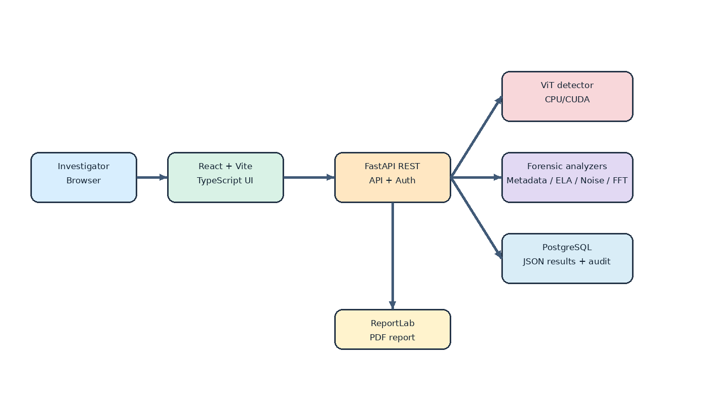
Figure 4.1: Overall system architecture
The browser communicates with FastAPI routes. FastAPI owns validation, authentication, detector orchestration, forensic analysis, aggregation and report generation. PostgreSQL stores users, scans, JSON results and audit events. File artifacts are stored under controlled scan-specific paths; filenames are not used as storage identifiers.

4.2 End-to-end Data Flow
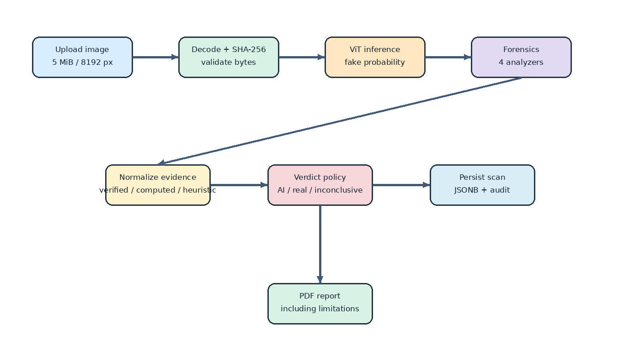
Figure 4.2: End-to-end image analysis workflow
The flow intentionally separates the model result from forensic observations. The evidence normalizer assigns categories and retains limitations. Verdict logic uses model thresholds and selected heuristic anomaly checks; missing metadata is not treated as proof of generation.

4.3 Sequence of a Scan
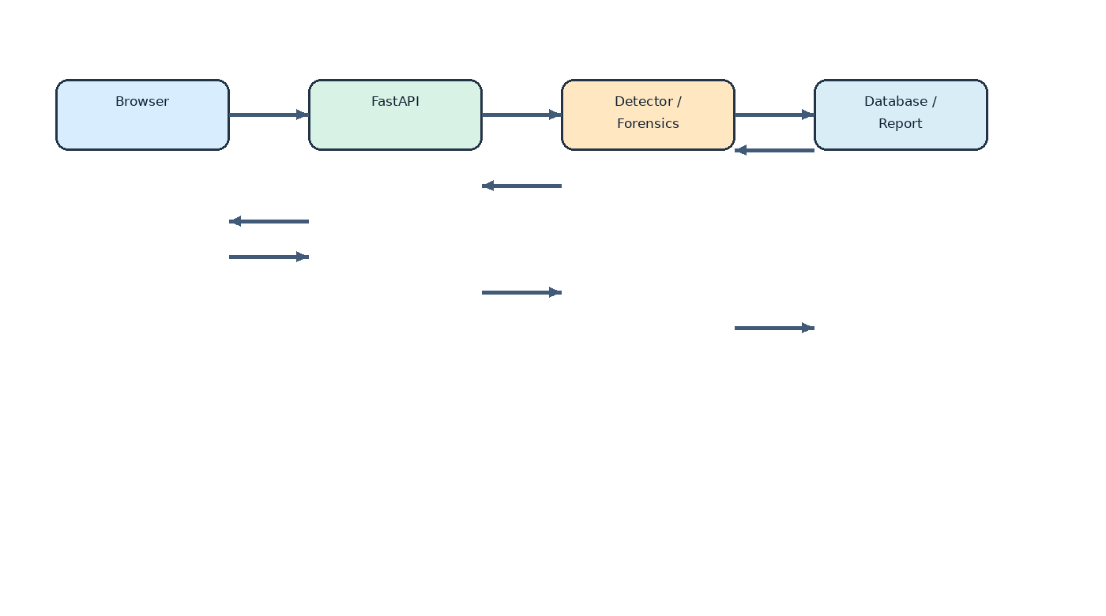
Figure 4.3: Scan interaction sequence
Authenticated browser session submits an upload. API validates content and creates an ownership-bound scan. Detector and analyzers execute, artifacts are written, result is persisted and response is returned. PDF download retrieves the persisted structured result and renders a report.

4.4 Component Responsibilities
Component | Responsibility
React/Vite client | Landing, login, dashboard, upload, results, archive and report affordance.
FastAPI main | Routes, lifecycle, auth integration, orchestration and error handlers.
Detector adapter | Pinned model loading, device selection, inference, attention artifact.
Forensics runner | Executes metadata, ELA, noise and frequency analyzers.
Aggregator | Evidence normalization, verdict and investigator sections.
SQLAlchemy/Alembic | Users, scans, ownership, JSON result persistence and schema migrations.
ReportLab report | Human-readable PDF with evidence, limitations and artifacts.

4.5 API Interaction Flow
Method | Route | Purpose
GET | /api/health | Health and detector status.
POST | /api/auth/login | Create authenticated session.
POST | /api/scans | Upload and analyze image.
GET | /api/scans | Paginated owned/history list.
GET | /api/scans/{id} | Retrieve structured scan.
GET | /api/scans/{id}/report.pdf | Download PDF report.
GET | /api/artifacts/{path} | Serve controlled scan artifacts.
GET | /api/admin/audit | Admin audit view, protected.

4.6 Database Design
The Scan model stores UUID, timestamps, input metadata, model output, verdict fields, owner reference and a full JSON result. User stores normalized username, Argon2id password hash, role and enablement. AuditEvent records bounded security events and actor references; it is application-auditable, not a tamper-proof ledger. Indexes support scan time, hash and ownership queries.

4.7 Security and Privacy
- Content is validated by decoding rather than trusting extension or MIME alone.
- Maximum upload and pixel dimensions bound resource consumption.
- SHA-256 provides content addressing and reproducibility reference.
- UUIDs and controlled artifact directories avoid raw client filenames on disk.
- Cookie routes use SameSite behavior and origin/CSRF checks; login and scan creation are rate limited.
- Audit entries exclude passwords, tokens, raw image bytes and unbounded request bodies.
- Retention, encryption at rest and production deployment hardening require institutional policy decisions.

CHAPTER 5 HARDWARE AND SOFTWARE REQUIREMENTS

5.1 Development Environment
Resource | Verified / documented requirement
Operating system | Linux development environment; deployment may use Docker Compose.
Python | Python 3.12 environment documented in release validation.
CPU/RAM | CPU fallback supported; exact minimum RAM not established.
GPU | NVIDIA CUDA is optional for inference acceleration; CPU path exists.
Frontend | Node.js/npm project using React, TypeScript and Vite.
Database | PostgreSQL via Docker Compose; SQLAlchemy and Alembic.
ML stack | PyTorch, torchvision, Transformers, PIL/Pillow, NumPy.
Testing | pytest, Playwright, TypeScript build and Oxlint.
Reporting | ReportLab for PDF generation; LibreOffice for document conversion.

5.2 Minimum Deployment Considerations
A CPU deployment is functionally possible but may have higher inference latency. GPU is recommended for interactive throughput, not mandatory by code design. A production deployment must define RAM, worker count, storage retention, TLS, secrets management, backup and monitoring limits; these values are not asserted here because they are not established by repository evidence.

5.3 Software Versions and Configuration
The repository pins model revision and records dependency files requirements-api.txt, requirements-ml.txt, pyproject.toml and frontend/package.json. Exact versions can change with environment lock state; the submitted source and lock files should be retained with this report for reproducibility.

CHAPTER 6 IMPLEMENTATION

6.1 Frontend and Upload Workflow
The React single-page client implements landing, authentication, investigator dashboard, upload preview, result cards, evidence details, archive and PDF report affordance. The captured workflow uses a real image from datasets/real/real_000002.jpg against the running staging stack. Guest actions are gated and authenticated routes are protected.

Figure 6.1: PHANTOM PHOENIX landing page captured from running application
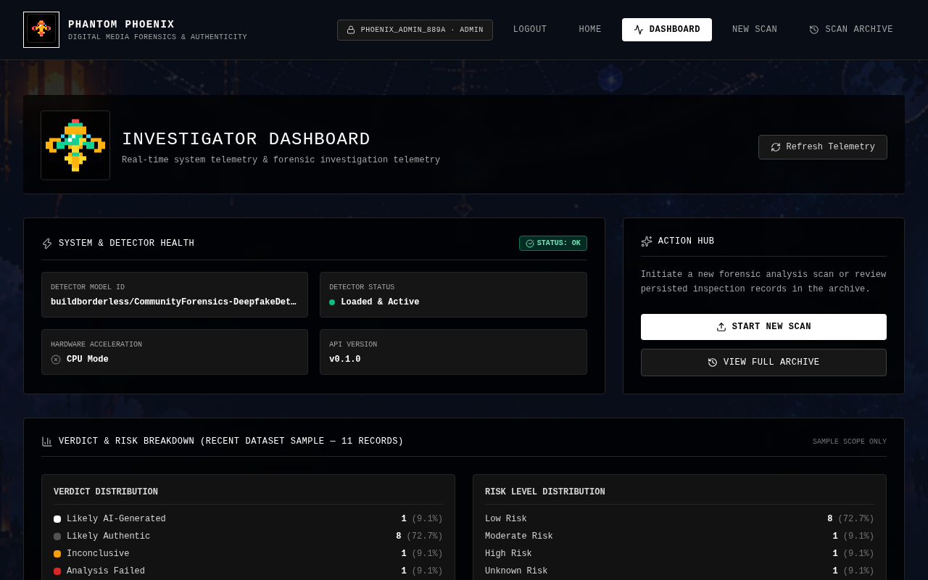
Figure 6.2: Authenticated investigator dashboard captured from running application
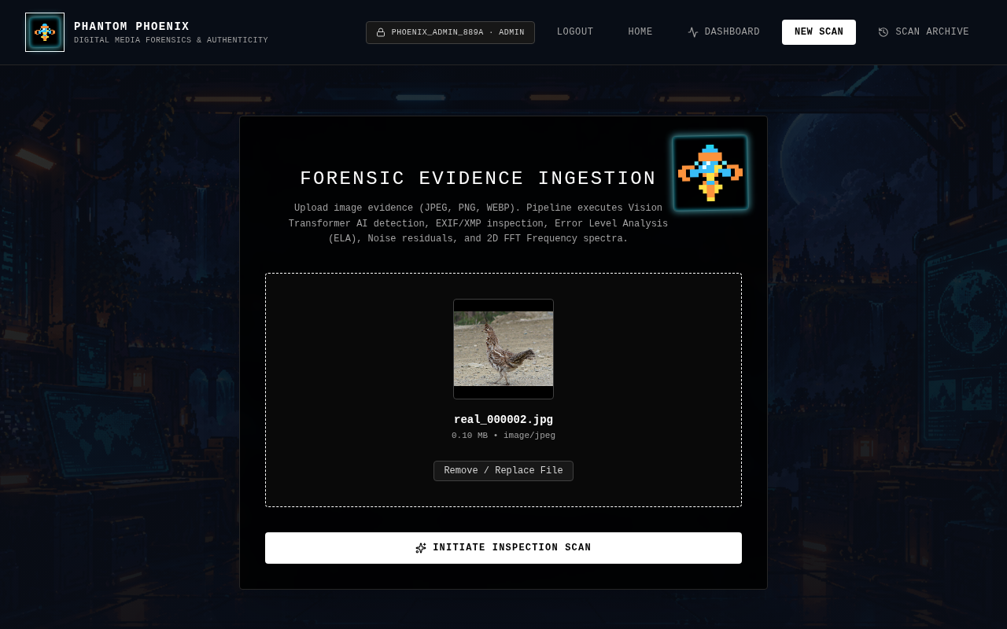
Figure 6.3: Image upload interface with staged real image

6.2 Backend API and Validation
FastAPI routes implement health, authentication, scan creation, scan retrieval, report download, artifact serving and protected audit access. Image validation uses actual decoding, dimensions and byte bounds. Exceptions are converted into structured validation or analysis errors rather than leaking internal failures.

6.3 AI Detector
DetectorAdapter is a thread-safe singleton. It loads the configured ViT model and processor once, validates expected model semantics, selects CUDA or CPU, runs inference with output attentions and records elapsed time, device, model identity and limitations. Attention rollout metrics and an attention-derived heatmap artifact are available when tensors are valid. The heatmap indicates attention focus; it is not a pixel-level proof of manipulation.

6.4 Metadata and Forensic Modules
Forensic modules share a ForensicContext containing the decoded PIL image, hash, scan identifier, media type, dimensions and original filename. Each analyzer returns a typed result, method, status, interpretation, limitations and optional artifact. This contract allows new analyzers without changing orchestration.
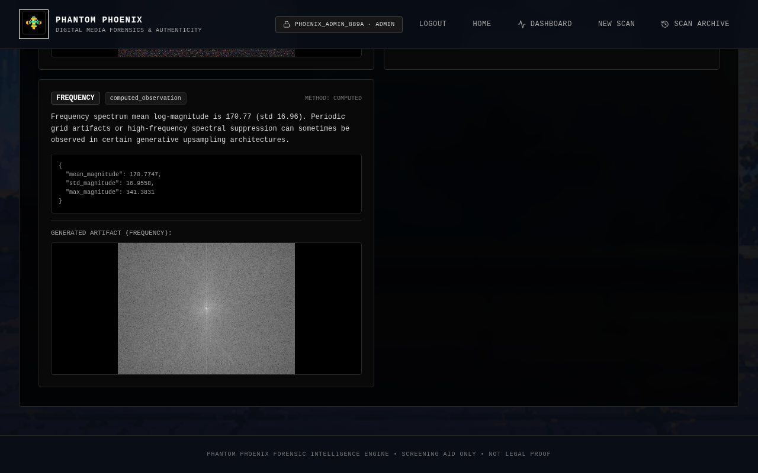
Figure 6.4: Metadata and normalized evidence findings
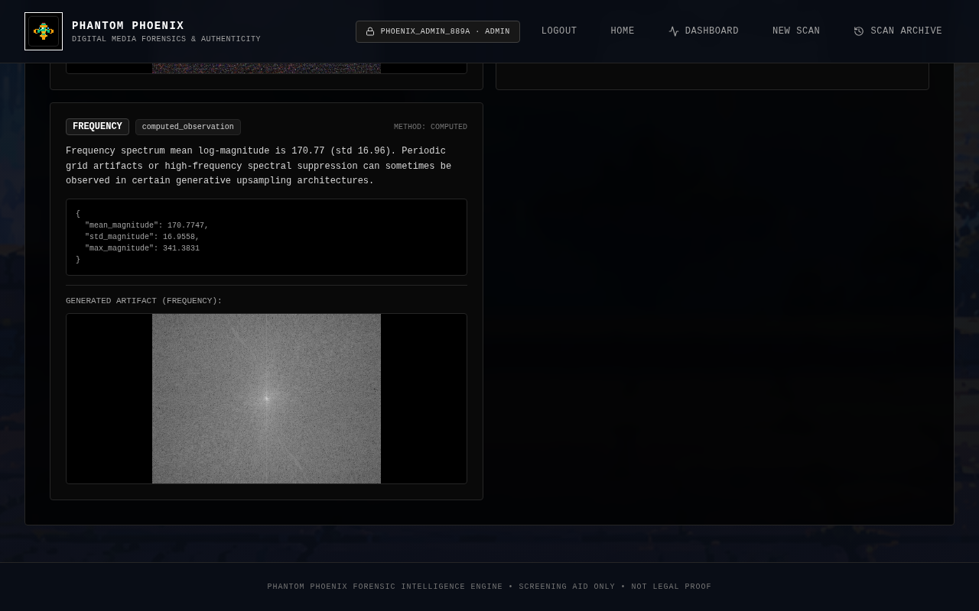
Figure 6.5: Forensic artifacts served by the running application (ELA/noise/frequency-style artifacts; not claimed as a Grad-CAM image)

6.5 Evidence Aggregation and Verdict
normalize_evidence converts detector and indicator outputs into NormalizedEvidenceItem records. Categories distinguish model inference, computed observation, heuristic evidence, verified evidence and unavailable information. aggregate_assessment applies threshold rules, counts selected heuristic anomalies and builds a verdict rationale with explicit not_claimed fields.
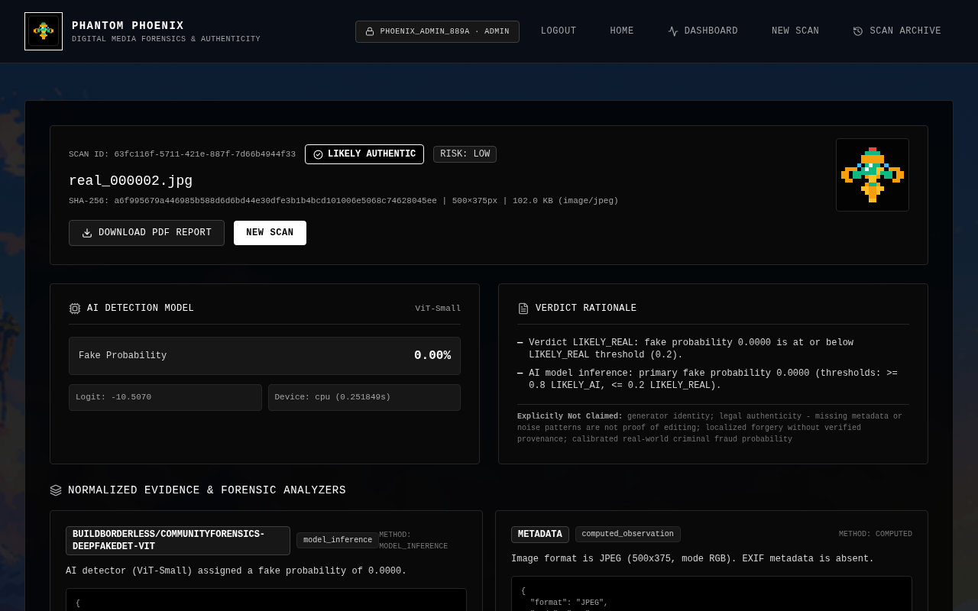
Figure 6.6: Authenticity result view after real detector inference

6.6 Persistence, Authentication and History
Users, ownership and audit events were added through Alembic migrations. Scan records persist full_result JSON for API compatibility while retaining indexed columns for common queries. The archive screen retrieves real scan history from /api/scans. Cross-user access is designed to avoid existence disclosure through uniform not-found behavior.

Figure 6.7: Scan archive populated by running application

6.7 Investigator Report and PDF
The PDF report includes executive summary, input properties, model output, forensic indicators, artifact references and six investigator sections. Unsupported source discovery, publisher intelligence, generator attribution and external evidence are rendered with status and limitations instead of fabricated claims.
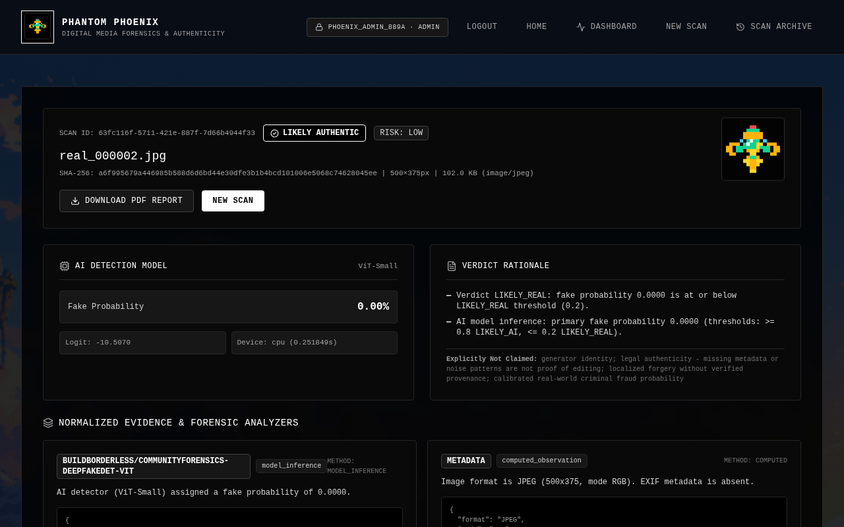
Figure 6.8: Results page showing verified PDF report download affordance

CHAPTER 7 TESTING, RESULTS AND DISCUSSION

7.1 Test Strategy
Testing combines deterministic unit tests for image utilities, analyzers, aggregation and verdicts; integration tests for PostgreSQL; API and security tests; frontend TypeScript/build/lint checks; Playwright smoke tests; and manual live-stack verification. Database tests are environment-sensitive and are reported separately when skipped.

7.2 Repository Test Evidence
Evidence | Result / status | Source
Backend release validation | 190 collected; 179 passed; 11 skipped for optional DB/E2E flags | docs/PHASE_2_6_RELEASE_VALIDATION.md
Historical milestone summary | 170 passed; 11 skipped | PHASE_2_IMPLEMENTATION_SUMMARY.md
Frontend production build | Exit 0; 1,920 modules; Vite bundle generated | report assists/TEST_RESULTS.md
Frontend typecheck | Exit 0 | report assists/TEST_RESULTS.md
Playwright smoke | 4 passed | report assists/TEST_RESULTS.md
Live authenticated workflow | Login, upload, inference, artifacts, archive and PDF download passed | report assists/TEST_RESULTS.md
The counts above are dated evidence from repository records. They are not silently presented as a fresh execution in this report. A final submission should rerun the commands in the QA checklist on the target machine and attach outputs.

7.3 Baseline Evaluation
Metric | Value | Protocol
Samples | 1,123 | Current baseline manifest
Accuracy | 0.6705 | Threshold 0.50
Precision (AI) | 0.9956 | Threshold 0.50
Recall (AI) | 0.3788 | Threshold 0.50
F1-score | 0.5488 | Threshold 0.50
ROC-AUC | 0.8965 | Ranking metric
PR-AUC | 0.9176 | Ranking metric
Inference errors | 0 | Manifest record

7.4 Confusion Matrix
 | Predicted real | Predicted AI
Actual real | 528 (TN) | 1 (FP)
Actual AI | 369 (FN) | 225 (TP)
This matrix demonstrates high precision and low false-positive rate at threshold 0.50, but also substantial false negatives. It must not be interpreted as universal performance: the result depends on dataset composition, split discipline, generator families, preprocessing and threshold.

7.5 Threshold Calibration
A repository calibration summary reports validation performance at threshold 0.05 as accuracy 0.7591, precision 0.9734, AI recall 0.5182 and F1 0.6764. The operational policy uses 0.80 for LIKELY_AI and 0.05 for LIKELY_REAL, leaving an inconclusive interval. These thresholds support triage; they do not convert model scores into calibrated legal or real-world probabilities.

7.6 Live Application Evidence
The screenshot index records a live run against https://127.0.0.1:8443/ using headless Chromium at 1280×800. It documents real login, upload of datasets/real/real_000002.jpg, real model inference, evidence display, artifact HTTP 200 responses, archive rendering and a PDF response of 400,650 bytes with %PDF-1.4 header. Credentials and tokens were not shown in screenshots.

7.7 Limitations and Error Analysis
- The detector is a single external baseline and does not cover every current generator.
- The baseline evaluation shows a large false-negative count for AI-generated samples.
- Metadata absence is not evidence of generation; ELA/noise/frequency are not conclusive independently.
- Generator attribution is unsupported; source discovery and publisher intelligence are not searched.
- C2PA verification, video/audio analysis and reverse-image search are not implemented.
- Exact minimum hardware, retention policy and production throughput are not measured.

CHAPTER 8 CONCLUSION AND FUTURE SCOPE

8.1 Conclusion
PHANTOM PHOENIX delivers an implemented image-focused platform that joins upload validation, model inference, forensic observations, evidence aggregation, authenticated persistence and PDF reporting. Its strongest engineering contribution is transparency: the system records what was observed, how it was computed and what remains unavailable. Evaluation evidence shows useful ranking and precision behavior under a documented protocol, alongside a material recall limitation. Therefore the appropriate use is preliminary screening and investigator support, not absolute authenticity certification.

8.2 Future Scope
Area | Proposed work
A. Video integration | Video upload, container validation, adaptive frame sampling, per-frame detection, temporal consistency, face manipulation analysis, audio-video synchronization, video metadata and resource-aware aggregation.
B. Explainability | Grad-CAM or equivalent attribution evaluation, explanation quality studies and links between visual explanations and evidence summaries.
C. Generator attribution | Model-family estimation with cross-generator evaluation, unknown/inconclusive outputs and strict separation from verified provenance.
D. Content provenance | C2PA/Content Credentials verification, cryptographic signature checks and separation of signed provenance from metadata heuristics.
E. Platform improvements | Secure administrator dashboard, authorization, audit-log tooling, deployment monitoring, calibration, benchmarking, retention controls and performance optimization.
All items in Table 8.1 are proposed future work unless separately verified in a later release. In particular, the current repository’s attribution service deliberately returns unsupported; it does not infer a generator identity.

REFERENCES
[1] D. A. Coccomini, R. Caldelli, F. Falchi, C. Gennaro and G. Amato, “Cross-Forgery Analysis of Vision Transformers and CNNs for Deepfake Image Detection,” Proceedings of the 1st International Workshop on Multimedia AI against Disinformation, 2022, doi: 10.1145/3512732.3533582.
[2] Y.-J. Heo, W.-H. Yeo and B.-G. Kim, “DeepFake detection algorithm based on improved vision transformer,” Applied Intelligence, vol. 53, pp. 7512–7527, 2023, doi: 10.1007/s10489-022-03867-9.
[3] A. Dosovitskiy et al., “An Image is Worth 16x16 Words: Transformers for Image Recognition at Scale,” International Conference on Learning Representations, 2021, arXiv:2010.11929.
[4] Coalition for Content Provenance and Authenticity, “C2PA Technical Specification,” Version 2.2, 2025. [Online]. Available: https://spec.c2pa.org/specifications/specifications/2.2/index.html
[5] Y. Li, X. Yang, P. Sun, H. Qi and S. Lyu, “Celeb-DF: A New Dataset for DeepFake Forensics,” arXiv:1909.12962, 2019.
[6] B. Dolhansky et al., “The DeepFake Detection Challenge Dataset,” arXiv:2006.07397, 2020.
[7] PyTorch, “PyTorch Documentation,” [Online]. Available: https://pytorch.org/docs/stable/
[8] FastAPI, “FastAPI Documentation,” [Online]. Available: https://fastapi.tiangolo.com/
[9] PostgreSQL Global Development Group, “PostgreSQL Documentation,” [Online]. Available: https://www.postgresql.org/docs/
[10] Hugging Face, “Transformers Documentation: Vision Transformer,” [Online]. Available: https://huggingface.co/docs/transformers/
[11] PHANTOM PHOENIX repository, “Baseline Evaluation Report,” docs/BASELINE_EVALUATION_REPORT.md, 2026.
[12] PHANTOM PHOENIX repository, “Phase 2.6 Release Validation Report,” docs/PHASE_2_6_RELEASE_VALIDATION.md, 2026.
[13] PHANTOM PHOENIX repository, “Screenshot Index,” report assists/SCREENSHOT_INDEX.md, 2026.

APPENDIX A EVIDENCE AND COMPLETION CHECKLIST
Item | Status / action
Eight original templates inspected | Complete; originals preserved.
Team names | Repository records support Hari; Shreyas, Shree Raksha and Srinivas retained as reported project team candidates; confirm formally.
USNs | Missing; insert before submission.
Guide name/designation | Missing; insert and verify.
Academic year/date/place | Academic year and approval dates missing; insert.
Signatures/examiners | Missing; obtain physically/electronically as required.
Technical claims | Bound to source code, manifests, tests or cited sources.
Screenshots | Captured assets from running stack, indexed in report assists/SCREENSHOT_INDEX.md.
PDF preview | Generated if LibreOffice conversion succeeds; inspect representative pages.
Final human review | Required before institutional submission.

